BETHSAIDA BAPTIST CHURCH
MEMBERSHIP GUIDE
A handbook for every member of the House of Bethsaida,
“The church beside the road that lights the path of men”.
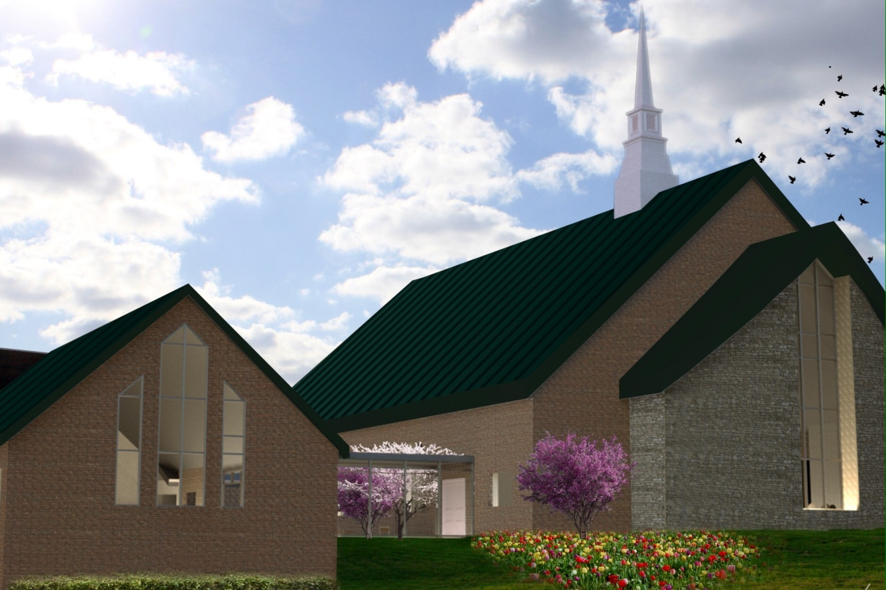

Bethsaida Baptist Church
3700 Tates Creek Road
Lexington, Kentucky 40517

Rev. (Dr.) Bishop E. Carter, III Pastor

“So then everyone of us shall give account of himself to God” Romans 14:12
Contents

1. Our Focus 4
2. Church Covenant 5
3. Declaration of Faith 6
4. Bethsaida’s Membership Code of Ethics 7
A. Tithes, Offering, Building Fund, etc… 7
B. Attendance and Stewardship 7
C. Leadership 8
D. Correspondence 8
E. Church Calendar – 8
5. Role of the Pastor 8
6. Role of Deacons, Trustees, and Church Officers. 9
A. Church Administrator 9
B. Deacons 9
C. Trustees 9
D. Church Receptionist 9
E. Church Clerk 9
F. Church Secretary 9
G. Church Custodian 9
H. Treasurer (Assistant Treasurer) 10
I. Financial Secretary (Assistant Financial Secretary) 10
J. Building Fund Chairperson 10
7. Role of Auxiliary Presidents and Officers 10
8. Role of Choir Director / Minister of Music 10
9. Church Meetings and Election of Officers 11
10. Services 11
11. Sunday School 12
12. New Members Class (Orientation) 12
13. Auxiliaries 13
14. Bible Study and Prayer Meeting 13
15. Baptist Training Union 13
16. Lord’s Supper 13
17. Men’s Breakfast with the Bible 14
18. Women’s Bible Study 14
19. Children’s Ministry 14
20. Seniors Ministry 14
21. Youth Ministry 15
22. Praise Performance Ministry 15
A. GUIdance 15
B. Bethsaida Mimes 15
23. Vacation Bible School or Back to School Program 15
24. Church Discipline through Pastoral & Christian Mentoring 16
25. The Mission of the Church 17
26. Announcements within the Church (and printing) 17
27. Envelope of the Church 18
28. This Week at Bethsaida 18
29. Church Poet – 18
30. TNT – Tuesday Night Tutoring 19
31. Simmons College of Kentucky (HBCU) 19
32. Executive Board Committee 19
33. Omega Psi Phi Fraternity, Inc. 19
34. Consolidated Baptist District Association – 20
35. Sons of Bethsaida 20
36. Church Officers and Staff 2

- Our Focus

Continuing the Bethsaida Tradition

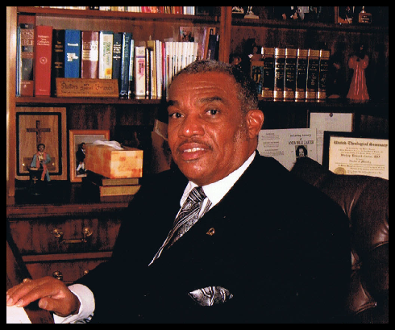
Greetings in the name of our Lord and Savior Jesus Christ:

On behalf of the Bethsaida Baptist Church family, I am happy to continue my pastoral practice of the “Bethsaida Tradition” in this form known as the Bethsaida Church Membership guide. Being a historical people, coming from the mainstream and roots of the belief of the Gospel of Jesus Christ, my focus, being led by the Holy Spirit is that all of us here at Bethsaida shall give an account unto God physically and spiritually. And, because of our required servitude, all of us shall also discipline ourselves morally and ceremonially through the church according to the word of God.

It is my prayer that this handbook, being a guide for enlightenment, will aid in our spiritual maturity, education and accountability to our Lord and Savior. There should always be the desire to challenge our stewardship to improve our personal contribution to Kingdom Building.

God Bless,

Rev. (Dr.) Bishop E. Carter, III

- Church Covenant

Having been led, as we believe, by the Spirit of God to receive the Lord Jesus Christ as our Savior, and on the profession of our faith, having been baptized in the name of the father, and of the Son, and of the Holy Spirit, we do now in the presence of God, angels and this assembly, most solemnly and joyfully enter into covenant with one another, as one body in Christ.
We engage, therefore, by the aid of the Holy Spirit, to walk together in Christian love, to strive for the advancement of this church in knowledge and holiness, to give it a place in our affections, prayer and services above every organization of human origin, to sustain its worship, ordinances, discipline and doctrine, to contribute cheerfully and regularly as God has prospered us, towards its expense, for the support of an evangelical ministry among us, the relief of the poor and the spread of the Gospel throughout the world. In case of difference of opinion in the church we will strive to avoid a contentious spirit, and if we cannot unanimously agree, we will cheerfully recognize the right of the majority to govern.
We also engage to maintain family and secret devotion, to study diligently the word of God, to religiously educate our children, to seek the salvation of kindred and acquaintance, to walk circumspectly in the work, to be kind and just to those in our employ, and faithful in the serve we promise others, endeavoring in the purity of heart and good will towards all men to exemplify and commend our holy faith.
We further engage to watch over to pray for, to exhort and stir up each other unto every good word and work, to guard each other's reputation, not needlessly exposing the infirmities of others, to participate in each other's joys and with tender sympathy bear one another's burdens and sorrows, to cultivate Christian courtesy, to be slow to give or take offense, but always ready for reconciliation, being mindful of the rules of the Savior in the eighteenth chapter of Matthew, to secure it without delay, and through life, amid evil report, and good report, to seek to live to the glory of God, who hath called us out of darkness into His marvelous light.
When we remove from this place, we engage as soon as possible to unite with some other church where we can carry out the spirit of this covenant and the principles of God’s Word.

- Declaration of Faith

Reference “A Baptist Church Manual” by J. Newton Brown, DD.

- Of the Scriptures
- Of the True God
- Of the Fall of Man
- Of the Way of Salvation
- Of Justification
- Of the Freeness of Salvation
- Of Grace of Regeneration
- Of Repentance and Faith
- Of God’s Purpose of Grace
- Of Sanctification
- Of the Perseverance of Saints
- Of the Harmony of the Law and the Gospel
- Of a Gospel Church
- Of Baptism and the Lord’s Supper
- Of the Christian Sabbath
- Of Civil Government
- Of the Righteous and the Wicked
- Of the World to Come

- Bethsaida’s Membership Code of Ethics

As a member of Bethsaida Baptist Church, I promise to uphold the church covenant, maintain good and regular standing in attendance, perform tithing and offering and support the Building Fund and all other fundraisers of the church. I will always be decent and in order with my conduct in public as well as at this church. My spiritual goal of development will include being mission-minded and always willing to help somebody, especially those of my church family and this community. Furthermore, I agree to act or participate in:

Tithes, Offering, Building Fund, etc…
Tithes: I will tithe one tenth (10%) or more of my income to the church annually.
Offering: I will give above and beyond my tithe to promote Kingdom Building at the church (for example: offering to Sunday School, Mission Fund, etc…)
Building Fund: I will participate and fulfil my pledge to the Building Fund

Attendance and Stewardship
Bible Class, Sunday School, Worship Services, Revivals, Workshops, CDBA and Educational/Community affairs.

Every one of us (church members) shall give an account of himself/herself to the church. It is to be understood that servitude is your duty - this applies to every child, youth and adult...none too young and none too old.

Leadership
It shall be understood that all members in leadership capacity will:
- Tithe
- Remain in good standing with regular attendance
  - Be present at least three (3) Sundays a month
  - Attend Bible Study and Prayer Meetings
  - Maintain spiritual discipline at all times
  - Attend Sunday School
  - Attend Workshops, vacation Bible School, revivals, etc... as called for
NOTE: At no time will a president of an auxiliary of the church be allowed to continue in a leadership capacity and not fulfill the criteria expected.

Correspondence
Any and all church related correspondence must have prior approval from the pastor before mailing or speaking to a church or a group.

Church Calendar –
This is the scheduled operating and functioning of church. All auxiliaries must comply with the church calendar for their programs.
- Role of the Pastor

The Pastor is the under-shepherd of the flock. It is his responsibility to feed, nurture and direct the people of God as God directs and leads him. God gives him the vision. All auxiliaries are under the direction of the Pastor. The entire church is under his care. All preaching, teaching, evangelism, etc., is provided and directed by the Pastor. At no time does anyone have the authority to invite, direct, extend the privilege of speaking or preaching from the pulpit of Bethsaida unless the Pastor approves it. (Refer to Baptist Manual for additional information)

- Role of Deacons, Trustees, and Church Officers.

Church Administrator
The church administrator is an assistant to the Pastor. The church administrator assists the pastor in his administrative duties, oversees the maintenance of the physical facility and facilitates and leads the Executive Board of the church.

Deacons
Deacons are the pastor’s helpers. They are approved by the church to serve in the capacity. They are to be full of the Holy Ghost, honest and ready to serve at all times. Their main function is to follow the directions of the pastor, be a dedicated, consistent worker in the church, serve the Lords Supper table, serve the financial tables and to see to widows and fatherless children. They must be tithers and financial stewards of the church.

Trustees
Trustees are the church’s representatives to deal with the property and laws of the state to the best interest of the church. They are appointed by the church and the Pastor.

Church Receptionist
The Receptionist serves as the communicating agent at the church on a daily/weekly schedule. Also assists the Pastor and church administrator with the administrative needs of the church

Church Clerk
The Church clerk is the official recorder of the church. The main duty is to keep adequate records of the church meetings, membership and assignments.

Church Secretary
The Church Secretary serves to aid the pastor, the church and the church administration. The primary responsibility is to be the main advocate for clerical duties of the church and involvement in the community.

Church Custodian
The church Custodian is to keep the church facility clean, respectable and presentable at all times (inside and outside). The custodian is to use sound judgment in the maintenance needed for the upkeep of the church.

Treasurer (Assistant Treasurer)
The Treasurer is the custodian for the care and control of church financials as authorized and to be prepared to give a financial report upon request.

Financial Secretary (Assistant Financial Secretary)
This position is responsible for recording the church's finances and to be prepared to give a financial report upon request.

Building Fund Chairperson
The Building Fund chairperson is the custodian for the care and control of building fund income until such time as the monies are turned in to the central treasury and to keep appropriate and accurate records in order to be prepared to give a financial report upon request. The chairperson is also responsible for promoting and aiding in building fund projects.
- Role of Auxiliary Presidents and Officers

Auxiliary presidents and officers are to be accountable, dependable, responsible, respectable, supportive, and a tither of the church. Auxiliary officers are to carry out the duties of the named body to which elected during the current term of service. Officers can only serve and carry out that which has been approved by the body. All auxiliary presidents are asked to be present or to send a representative to Executive Board Meetings. Executive Board Meeting dates are set by the Church Administrator and announced in the church bulletin.
- Role of Choir Director / Minister of Music

The Choir director and/or Minister of Music is to provide the instructional leadership for the choirs and is to work with the officers of the choir. The choir is an auxiliary of the church. The choir director/minister of music is appointed by the church and advised by the Pastor and Church Administrator. Special note: A performance by any choir or commitment to perform by any choir outside of Bethsaida must have prior approval from the Pastor and Church Administrator.

- Church Meetings and Election of Officers

Church meetings are planned and announced by the Pastor. Normally, the annual church meeting is in December. Election of church officers is done at this time. Auxiliary elections should be done 30 days before the annual church meeting to coincide with the new year administration.

There should be a two week announcement given for church meetings unless there is urgent business that can be solved in a called business meeting.

Auxiliaries should announce the election of officers two weeks prior for fairness and to keep a cooperative spirit. All new auxiliary officers are to be elected by the third Sunday of November. The length of holding office shouldn't exceed two consecutive terms allowing for a democratic observance & opportunity.
- Services

- Sunday Services
8:00 am Early Morning Worship
9:20 am Sunday School
10:45 am Devotions
11:00 am Worship

- Tuesday Services - Pastoral Counseling, 5-6:30pm.
Bible Study and Prayer Meeting at 6:30 pm - 8:00pm.
***TNT (Tuesday Night Tutoring) – this session provides an opportunity for both children and youth to connect with tutors that can give them academic help. The Tutors are dedicated members of the church who have an enrich background in teaching, Social skills, experienced in the basic fundamentals of moral behaviour, and religious principles. Also the Psi Tau Graduate Chapter & the Rho Lambda Chapter of the University of Kentucky of Omega Psi Phi Fraternity, Inc., Lexington, Kentucky, have been volunteer Mentors & Tutors at Bethsaida for Tuesday Night Tutoring since 1999.

- Sunday School

Bethsaida’s Sunday School is unique, well planned and instructed by qualified and dedicated teachers and officers. It is our intent to keep it as a vital part of the religious education arm of Bethsaida. Teachers are chosen by the pastor. Teachers are to attend monthly teachers meetings. The superintendent, assistant superintendent and officers are elected each year. The superintendent is to administer the school (teachers, classes, students, books, programs), coordinate programs & the decorating of the Christmas tree, assist with vacation bible school, back to school, etc. this office is closely tied to the program set forth by the Pastor.

The Sunday School shall plan an annual trip (picnic, zoo…), recruit students through evangelism and work at improving attendance by cooperative efforts within the church & the community.
- New Members Class (Orientation)

By taking the time to orient our new members to the privileges and responsibilities of church membership, it is our hope at Bethsaida to have a more educated, involved, and encouraged members. An important goal of the new members class is to give an overview of the church including its services, focus, and programs. During the four part weekly series, it is our hope that the new members become acquainted with Bethsaida as well as each other. The teacher of the new members class is appointed by the Pastor, if not the Pastor.

- Auxiliaries

Sunday School
Bible Class
Baptist Training Union
Children’s Group
Building Committee
Children’s Choir
Voices of Bethsaida
Disciples of Bethsaida
Pastor’s Aide
Senior Ministry

Praise Performance Ministry
Catherine Walker Missionary Society
Senior Choir
Usher Board
Emergency Committee
Kitchen Committee
Baptism Committee
Bus Committee
Building Fund
Praise Performance Ministry

*Cooperative Club
Willing Workers Club
Youth Mentoring Ministry
Brotherhood
1982 Club – New Edition (Youth)
Executive Board
Tuesday Night Tutoring
Women's Bible Class
Breakfast with the Bible (Men)

- Bible Study and Prayer Meeting

Bible Study and Prayer Meeting is held on Tuesdays at 6:30 pm. The pastor and education coordinator of the church strongly encourage church member participation in bible study and prayer meeting. The instructors for the bible study are the pastor and appointed church members.
- Baptist Training Union

The Baptist Training Union (BTU) is conducted on the first Sunday of each month following morning worship service. It is taught by the BTU superintendent focusing on the Baptist Church Manual (Declaration of Faith), the Church Covenant and These Things we Believe - members responsibility in the New Testament Church.
- Lord’s Supper

The observance of the Lord’s Supper is the first Sunday of each month following worship and Baptist Training Union. The main focus is the commemoration of the death, burial and resurrection of Jesus Christ, and that all of the believers are to examine themselves.

- Men’s Breakfast with the Bible

On the third Saturday of every month, the men of Bethsaida gather to fellowship and discuss the word of God. They invite men of all ages of the church to participate regularly in an effort to foster friendships, to provide support and to encourage one another’s Christian walk.
- Women’s Bible Study

On the second Saturday September through May, the women of Bethsaida gather to fellowship and discuss the word of God. They invite w men of all ages of the church to participate regularly in an effort to foster friendships, to provide support and to encourage one another’s Christian walk.
- Children’s Ministry

It has been a tradition of Sunday Morning service at Bethsaida to set time aside for Children’s Hour. Children up to age 12 are highlighted during this time. Our goal is to help each child feel part of Sunday morning service and give them an opportunity to express their thoughts and responses to the children’s hour topic.

Additionally, children’s church is held on the 2nd and 4th Sundays during 11am worship service while school is in session. After Children’s Hour, the children are dismissed to the fellowship hall for their own service which consists of a lesson and sometimes crafts.
- Seniors Ministry

A Ministry for our senior citizens that focuses on inclusive recognition, visitation, special dinners (such as the Christmas Senior Dinner), a quarterly Newsletter, and having them mentor to the congregation as much as possible.

- Youth Ministry

The Youth Ministry promotes participation of youth of all ages in the church. In addition, the youth are provided with cultural and social opportunities at the church and within the community.

The Youth Ministry at Bethsaida, includes the 1982 Club and mentoring programs (Male Mentoring and Girls Rock). Youth are considered ages 12 – 18.

The youth music ministry of Bethsaida, the Jr. Voices of Bethsaida, provide musical opportunities for all age groups of children. Our goal is to help each participant learn to express their love of God in the form of music and to develop an understanding of the role of music in worship. The children gain music skills and an appreciation of music.
- Praise Performance Ministry

The Praise Performance Ministry is designed to give youth another opportunity to express their praise to God through dance, mime and eventually drama.

GUIdance
Is our praise dance ministry. GUI Dance (pronounced Guy-dance) stands for God, You, and I Dance. Youth from the age of 9 years and above are encouraged to participate. From time to time, we may have special performances geared toward younger dancers.

Bethsaida Mimes
Technically a part of the praise dance ministry, the Mimes perform using the technique of miming. Members of the group are primarily male and focused on youth ages 9 and up.

- Vacation Bible School or Back to School Program

Vacation Bible School or Back to School Programs summer religious education projects that are geared to educating, evangelizing, soul winning and fellowshipping through a 3-5 day program. The program date is coordinated with the pastor and teaching staff.
- Church Discipline through Pastoral & Christian Mentoring

It must be understood that discipline is a priority of God. God is a God of order. When there is a disturbance and the pastor is made aware of, efforts to resolve will be done according to scripture (Matthew 18:15-20). As a member of the church, you are to carry out the first step: “Moreover if the brother shall trespass against thee, go and tell him his fault between thee and him alone; if he shall hear thee, thou hast gained they brother. But if he will not hear thee…” If and when occurrences prevail that pertain to the interest of the church being forfeited or disturbed, the pastor will prayerfully use his best judgment.

- The Mission of the Church

The mission of the church is done through worship, praise, evangelism, Sunday School, Bible Studies, Tutoring (TNT), Bible Schools, Emergency Response mission funds (natural disaster relief, homeless and jobless), & outreach missions such as:

- Black Church Coalition
- Kentucky State Alumni Scholarship Fund
- Habitat for Humanity
- Horizon Center
- Fraternity/Sorority Scholarships
- God’s Pantry
- Salvation Army
- Black Achievers
- BUILD
- CBDA
- General Association of Baptist in Kentucky
- Church Under the Bridge
- Youth Enhancement Programs
- Senior Citizen Auxiliary
- Simmons College of Kentucky
- Samaritain’s Purse Christmas

Our goal is to constantly promote our church theme by precepts and examples: “The Church beside the road that lights the path of men”.
- Announcements within the Church (and printing)

Announcements should be turned in two weeks prior to the event to the church secretary and publicity staff. All announcements from the community need to be cleared through the pastor’s office.

- Envelope of the Church

Check No. _______
BETHSAIDA BAPTIST CHURCH
3700 Tates Creek Road
Lexington, KY 40517
Phone (859)272-0193

Name _____________________________ Date ______________________

General Offering $_____________________________________________
Tithes $_____________________________________________
Bldg. Fund $_____________________________________________
Mission $_____________________________________________
Special Offering $_____________________________________________
Total Offering $_____________________________________________

When completing a church envelope, please be sure to indicate how you would like to have your money applied. Use the Special Offering line to indicate the amount of the gift along with an explanation of what it is for. (For example: 20.00 (youth day)). It is not necessary to write multiple checks, just use lines on the envelope to indicate how your gift needs to be applied.
- This Week at Bethsaida

This Week (or weekend) at Bethsaida is a weekly online publication from the church secretary that highlights upcoming church activities and community events. The information is distributed weekly via email and posted to Facebook.
- Church Poet

The church poet promotes Christian Empowerment through narratives and poetic stories.

- TNT – Tuesday Night Tutoring

Tuesday Night Tutoring is a Mentoring & Tutorial program that focuses on enhancing the educational skills of the children & youth of the church. Psi Tau Chapter of Omega Psi Psi Fraternity, Inc., have contributed to this church as their community mandate in Mentoring & service since March, 2000.
- Simmons College of Kentucky (HBCU)

This is a Pilot Program and is Simmons College’s long distance school located at the Bethsaida Baptist Church. Classes are on Monday evening 6-9pm. Classes included a curriculum for acquiring AAS, BA, THB's degrees, & Certification in Business, Social, Education, & Biblical Studies. Dr. Bishop E. Carter III, Pastor, is the Director and Faculty Member.
- Executive Board Committee

This is an inclusive representation of the church officers & auxiliaries presidents of the church. Its goal is to unite the various auxiliaries and encourage conversation among the auxiliaries, “United we stand, divided we fall.” The Church Administrator sets meetings.

- Omega Psi Phi Fraternity, Inc.

The Psi Tau Graduate chapter meets every 3rd Saturday of the month at Bethsaida. The Fraternity has been meeting regularly at Bethsaida since 1996. They also provide a weekly Mentoring program (since 2000) through The TNT program, (Tuesday Night Tutoring). Dr. Carter is an active member. Other members of the church are: Deacon Charles Duke, Bishop E. Carter IV, Brandon "BJ" Carter, and Alex Mapp.

- Consolidated Baptist District Association –

The local African American Baptist District made up of 56 churches from 17 counties of the Bluegrass Region, Central Kentucky. This body is affiliated with the General Association of Baptist in Kentucky (the State Body-one of the oldest state association of churches in America, Black or White). +

- Sons of Bethsaida

- Rev. Richard Harless (Associate Minister)
- Rev. Tim Coleman (Associate Minister)
- Rev. Patrick Wilson (Associate Minister – Youth Minister)
- Rev. Don Johnson (Elder Minister)
- Min. Toby Mundy (Associate Minister)
- Min. James Jones (Associate Minister)
- Min. Tim Davis (Associate Minister)
- Pastor Will Howard – Evergreen Baptist Lawrenceburg
- Pastor Earl Ragland, Jr. - Macedonia Baptist Millville
- Pastor L. Rodney Bennett – 2nd Baptist Mayslick

- Church Officers and Staff

  - Church Administrator Prenell Mitchell

  - Deacons
      - Vincent Green
      - Byron Mitchell (Chairperson)
      - Craig Williams
      - Jackie Blanton Sr
      - Jackie Blanton Jr
      - Charles Duke
      - Ron Shelby
      - Terry Lipscomb
      - Ulysses Liggins (walking)
      - S.L. Moore (walking)

  - Finance Committee
      - Lytonya Williams
      - Casondra Jones
      - Kristy Jackson

  - Trustees
      - Vincent Greene (Chairperson)
      - Bishop Carter, IV
      - Hasker Worthy
      - Byron Mitchell
      - Craig Williams
      - Finance Committee

  - Clerical Staff
      - Emma Blanton (Church Clerk)
      - Ivy Barksdale (Church Secretary)
      - Estella Tatum (Asst. Church Clerk)
      - France Blackford (Asst. Church Secretary)
      - Sherry Jackson (Asst. Church Secretary)
      - Linda Leach (Asst. Church Secretary)
      - Taye’ Wheat (Asst. Church Secretary)
      - Teresa Bates (Church Receptionist)

  - Auxiliaries
      - Teresa Bates (Co-Culinary)
      - Sabrina Liggins (Co-Culinary)
      - Emma Blanton (Missionary President)
      - Peggy Prentice (Missionary Vice-President)
      - Ladonna Douglas (BTU)
      - Sherry Jackson (Sunday School assistant)
      - Brenda Carter (1982 Club)
      - Charles Wheat (Usher Board President)
      - Adrianne Worthy (Seniors Ministry Vice Pres)
      - Florence Jackson (Seniors Min. Pres/Sunday School Sec.)
      - Courtney Hart (Youth Mentoring/Online Presence Manager)
      - Patrick & Felicia Wilson (Willing Workers)
      - Jackie Blanton, Jr. (Voices President)
      - Liz Garner (Voices Vice-President)
      - Adrienne Worthy (Education Director)
      - Ivy Barksdale (Praise Performance)
      - Ron Shelby (Bus Ministry)
